Homework Tasks:   
Choose a real-world dataset and perform a classification task using both SVM   
and logistic regression. Compare the model performance.   
Write a brief report summarizing your findings, including the dataset used, data   
preprocessing steps, model implementation, evaluation metrics, and a   
discussion of the results

For the data set I have chosen the heart failure prediction from Kaggle

<https://www.kaggle.com/datasets/fedesoriano/heart-failure-prediction>

before the data got to ML part we did a fast label encoder for the data

changed the data from cat to numerical one

and used both SVM ( SUPPORT VECTOR MACHINE )

and the logistic regression

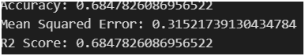

The SVM has achieved

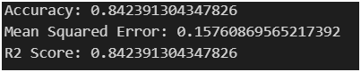

The logistic regression

For this data set the logistic regression has achieved better results

With accuracy , MSR and r2

For the task 2.2 both of algorithm’s (SVS and Logistic Regression

) has achieved very similar results to even identical one